**10) How to add story points on the dashboard (With the help of an example create one in**

**tableau)**

In Tableau, a story is a sequence of sheets or dashboards that work together to convey information or tell a data-driven narrative. Story points are specific views within a story that highlight key insights or guide the viewer through the data story. Adding story points to a dashboard in Tableau involves creating a story and then adding individual story points with the desired visualizations.

Here are the steps to add story points to a dashboard in Tableau:

**Step 1: Create a Story**

1. **Create a Dashboard:**

* Build the initial dashboard with the visualizations you want to include in your story.

1. **Switch to Story View:**

* At the bottom of the screen, click on the "Story" tab.

1. **Create a New Story:**

* Click on the "New Story" button in the Story tab.

**4.Name Your Story:**

* Give your story a meaningful title by clicking on the "Story Title" placeholder and entering the desired name.

**Step 2: Add Story Points**

1. **Add a Blank Story Point:**

* In the story view, click on the "+" button to add a new story point. This will create a blank story point.

1. **Add Sheets to the Story Point:**

* Drag the sheets or dashboards you want to include in the story point from the Sheets tab to the story point.

1. **Customize the Story Point:**

* Adjust the size and placement of the sheets within the story point.
* You can also add text, annotations, or images to provide context or explanations.

1. **Create Additional Story Points:**

* Add more story points by clicking on the "+" button and repeating the process. Each story point can represent a different view or insight.

1. **Arrange Story Points:**

* Drag and drop story points to rearrange the sequence of views in your data story.

**Step 3: Customize the Story**

1. **Format the Story:**

* Use the formatting options in the toolbar to customize the appearance of the story, including fonts, colors, and backgrounds.

1. **Add Captions and Annotations:**

* Add captions to individual sheets within story points to provide additional context.
* Use annotations to highlight specific data points or trends.

1. **Adjust Story Settings:**

* Click on the gear icon in the top-right corner to access story settings. Here, you can adjust settings such as navigation and auto-play options.

1. **Preview the Story:**

* Click on the "Start" button to preview how the story will flow. This helps you ensure a smooth narrative.

**Step 4: Save and Share**

1. **Save Your Workbook:**

* Save your Tableau workbook to preserve the story structure.

1. **Share the Story:**

* You can share your Tableau story as a Tableau Workbook (.twb) or as a Tableau Packaged Workbook (.twbx). Alternatively, you can publish it to Tableau Server or Tableau Online for wider distribution.

**In Tableau:**

**Prerequisites**: Superstore Data-source provided by Tableau, which includes three tables: orders, people, and returns.

**Orders Table**:

Columns: Order ID, Order Date, Ship Date, Ship Mode, Customer Name, Segment, Country/Region, City, State, Province, Category

**People Table**:

Columns: Regional Manager

**Returns Table**:

Columns: Returned

* Go to the Tableau web application.
* Bottom left you'll see a new story icon.



* Click on the new story and select the sheet you want to add.

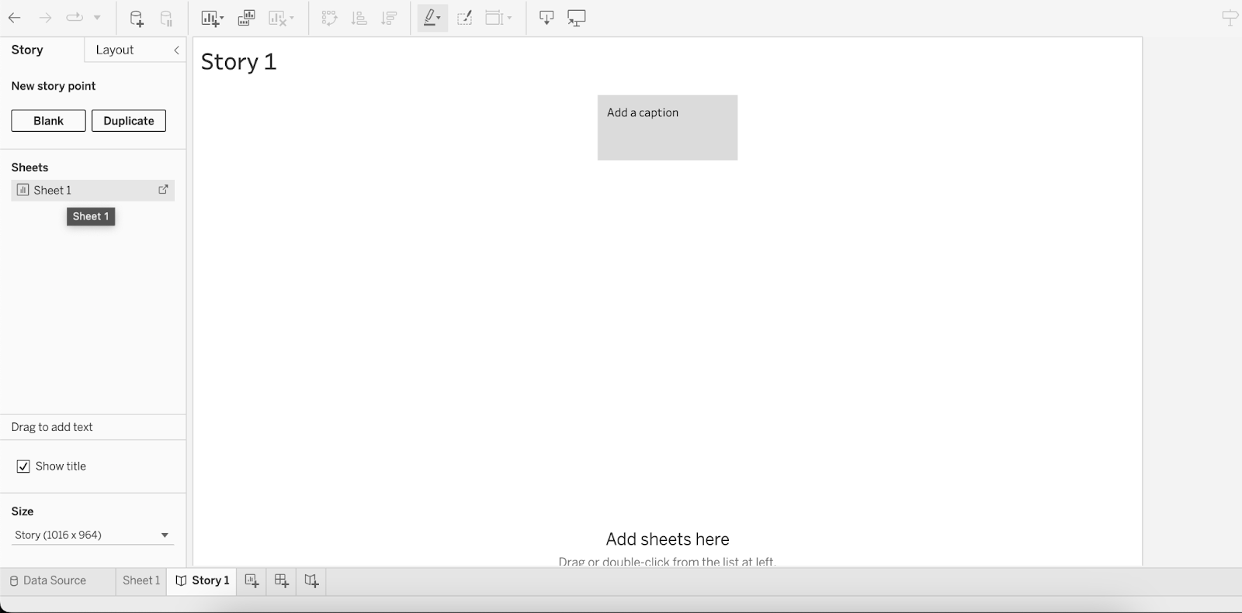

* Once you’ve added your sheet you can click on the blank or duplicate sheet to add more stories.

